

06/08/2012
WEEK 32 – 2012
In hierdie uitgawe...
- Voedselveiligheidsvereistes vir grondboonprodusente
- Vordering met leweringstempo van mielies

Voedselveiligheidsvereistes vir grondboonprodusente
Corné Louw (senior ekonoom: Bedryfsdienste, Graan SA)
►Grondboonprodusente is reeds sedert 2005 blootgestel aan voedselveiligheidsvereistes met betrekking tot die verbouing van grondbone. Die Departement van Landbou, Bosbou en Visserye gaan via die PPECB weer hierdie seisoen in erns begin om grondboonproduksie vir voedselveiligheidsdoeleindes op plaasvlak te oudit.
Daar is sekere voldoeningskriteria en kontrolepunte waaraan produsente moet voldoen en dit kan by die volgende skakel afgelaai word:
http://www.nda.agric.za/doaDev/sideMenu/foodSafety/doc/Checklist%20Prim%20Prod%20on%20farm%20prod%20hand-Rev%203%20August%202011%20final%20-%2011-5-2012.docx

Vordering met leweringstempo van mielies
Petru Fourie (ekonoom: Bedryfsdienste, Graan SA)
► Tabelle 1, 2 en 3toon die wit- en geelmielielewerings vir week een tot dertien van die huidige bemarkingsjaar (2012/2013). Die stroopproses het in die huidige seisoen baie vroeg momentum gekry en lewering is tans hoër as die langtermyngemiddeld. Die vroeë ryp sowel as die droogtetoestande het ‘n groot rol daarin gespeel dat produsente vroeg begin stroop het.
Tesame met die vroeë lewerings is daar tot dusver 5 315 miljoen ton (85,8%) van die geskatte 6 193 miljoen ton witmielie-oes tot dusver gelewer. Dit is duidelik sigbaar dat die witmielieleweringstempo dié seisoen heelwat vroeër in vergelyking met die vorige drie bemarkingsjare se lewerings is. Die Nasionale Oesskattingskomitee (NOK) het die sesde witmielie produksieskatting met 166 200 ton verlaag vanaf die vyfde produksieskatting.

Tabel 1: Witmielielewerings vir week 1 tot 13 (ton).
 | 2009/2010 | 2010/2011 | 2011/2012 | 2012/2013
Vroeë lewerings (week 44 tot 52) | 145 000 | 125 000 | 66 000 | 205 000
Bemarkingseisoenlewerings (week 1 tot 13) | 5 017 000 | 5 733 000 | 3 662 000 | 5 110 000
Totale lewerings (week 1 tot 13 plus vroeë lewerings) | 5 162 000 | 5 858 000 | 3 728 000 | 5 315 000
Oesskatting | 6 775 000 | 7 830 000 | 6 052 000 | 6 193 100
Persentasie | 76,2 | 74,8 | 61,6 | 85,8

In die huidige bemarkingsjaar is daar 4 039 miljoen ton (87,0%) van die geskatte 4 643 miljoen ton se geelmielie-oes gelewer. In die vorige drie bemarkingsjare was daar in dieselfde tydperk onderskeidelik 77,4%, 75,4% en 68,5% van die geelmielie-oes alreeds gelewer. Die NOK het die geelmielie-oes vanaf 4 496 miljoen ton (vyfde skatting) tot 4 643 miljoen ton (sesde skatting) verlaag.
Tabel 2: Geelmielielewerings vir week 1 tot 13 (ton).
 | 2009/2010 | 2010/2011 | 2011/2012 | 2012/2013
Vroeë lewerings (week 44 tot 52) | 225 000 | 129 000 | 124 000 | 334 000
Bemarkingseisoenlewerings (week 1 tot 13) | 3 857 000 | 3 632 000 | 2 825 000 | 3 705 000
Totale lewerings (week 1 tot 13 plus vroeë lewerings) | 4 082 000 | 3 761 000 | 2 949 000 | 4 039 000
Oesskatting | 5 275 000 | 4 985 000 | 4 308 000 | 4 643 500
Persentasie | 77,4 | 75,4 | 68,5 | 87,0

Die totale mielielewerings staan op 9 354 miljoen ton vir die eerste dertien weke van die 2012/2013-bemarkingsjaar. Tesame met vroeë lewerings is 86,3% van die geskatte 10 836 miljoen ton mielie-oes tot dusver gelewer en is die huidige jaar se totale lewerings ver voor in vergelyking met die vorige jare.
Tabel 3: Totale mielielewerings vir week 1 tot 13 (ton).
 | 2009/2010 | 2010/2011 | 2011/2012 | 2012/2013
Vroeë lewerings (week 44 tot 52) | 370 000 | 254 000 | 190 000 | 539 000
Bemarkingseisoenlewerings (week 1 tot 13) | 8 874 000 | 9 365 000 | 6 487 000 | 8 815 000
Totale lewerings (week 1 tot 13 plus vroeë lewerings) | 9 244 000 | 9 619 000 | 6 677 000 | 9 354 000
Oesskatting | 12 050 000 | 12 815 000 | 10 360 000 | 10 836 600
Persentasie | 76,7 | 75,1 | 64,4 | 86,3

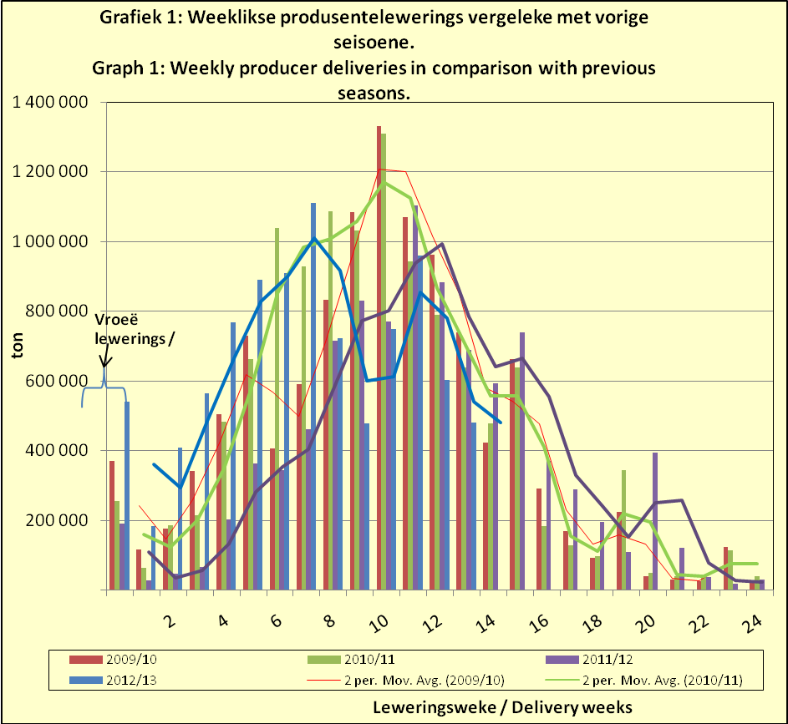

06/08/2012
WEEK 32 – 2012

In this issue…
- Food safety requirements for groundnut producers
- Progress with delivery tempo of maize

Food safety requirements for groundnut producers
Corné Louw (senior economist: Industry Services, Grain SA)

► Groundnut producers have since 2005 been exposed to food safety requirements with regards to the cultivation of groundnuts. Via the PPECB, the Department of Agriculture, Forestry and Fisheries will this season again begin in earnest to audit groundnut production for food safety purposes on farm level.

There are certain compliance criteria and control points that producers need to abide by and this can be downloaded from the following link:

http://www.nda.agric.za/doaDev/sideMenu/foodSafety/doc/Checklist%20Prim%20Prod%20on%20farm%20prod%20hand-Rev%203%20August%202011%20final%20-%2011-5-2012.docx

Progress with delivery tempo of maize
Petru Fourie (economist: Industry Services, Grain SA)

► Tables 1, 2 and 3 show the white and yellow maize deliveries for week one to thirteen of the current marketing year (2012/2013). Early momentum was gained in the harvesting process of the current season and delivery is currently higher than the long-term average. The early frost as well as drought conditions played a part in the early start of harvesting by producers.

Taking into account the early deliveries, 5 315 million ton (85,8%) of the estimated 6 193 million ton maize crop has been delivered thus far. It is abundantly clear that the white maize delivery tempo for this season is considerably earlier compared to the deliveries of the previous three marketing years. The National Crop Estimates Committee (NCEC) has lowered the sixth white maize production estimate with 166 200 ton from the fifth production estimate.

Table 1: White maize deliveries for week 1 to 13 (ton).
 | 2009/2010 | 2010/2011 | 2011/2012 | 2012/2013
Early deliveries (week 44 to 52) | 145 000 | 125 000 | 66 000 | 205 000
Marketing season deliveries (week 1 to 13) | 5 017 000 | 5 733 000 | 3 662 000 | 5 110 000
Total deliveries (week 1 to 13 plus early deliveries) | 5 162 000 | 5 858 000 | 3 728 000 | 5 315 000
Crop estimate | 6 775 000 | 7 830 000 | 6 052 000 | 6 193 100
Percentage | 76,2 | 74,8 | 61,6 | 85,8

In the current marketing year, 4 039 million ton (87,0%) of the estimated 4 643 million ton yellow maize crop has been delivered. During the same period of the previous three marketing years, respectively 77,4%, 75,4% and 68,5% of the yellow maize crop had already been delivered. The NCEC lowered the yellow maize crop from 4 496 million ton (fifth estimate) to 4 643 million ton (sixth estimate).
Table 2: Yellow maize deliveries for week 1 to 13 (ton).
 | 2009/2010 | 2010/2011 | 2011/2012 | 2012/2013
Early deliveries (week 44 to 52) | 225 000 | 129 000 | 124 000 | 334 000
Marketing season deliveries (week 1 to 13) | 3 857 000 | 3 632 000 | 2 825 000 | 3 705 000
Total deliveries (week 1 to 13 plus early deliveries) | 4 082 000 | 3 761 000 | 2 949 000 | 4 039 000
Crop estimate | 5 275 000 | 4 985 000 | 4 308 000 | 4 643 500
Percentage | 77,4 | 75,4 | 68,5 | 87,0

The total maize deliveries stand on 9 354 million ton for the first thirteen weeks of the 2012/2013 marketing year. With early deliveries taken into account, 86,3% of the estimated 10 836 million ton maize crop has thus far been delivered, putting the current year’s total deliveries far ahead compared to previous years.
Table 3: Total maize deliveries for week 1 to 13 (ton).
 | 2009/2010 | 2010/2011 | 2011/2012 | 2012/2013
Early deliveries (week 44 to 52) | 370 000 | 254 000 | 190 000 | 539 000
Marketing season deliveries (week 1 to 13) | 8 874 000 | 9 365 000 | 6 487 000 | 8 815 000
Total deliveries (week 1 to 13 plus early deliveries) | 9 244 000 | 9 619 000 | 6 677 000 | 9 354 000
Crop estimate | 12 050 000 | 12 815 000 | 10 360 000 | 10 836 600
Percentage | 76,7 | 75,1 | 64,4 | 86,3

